**Thurston County Water Resources**

**Technical Memorandum #7b**

Lake St. Clair Elevation and Eaton Creek Discharge  
2008-2016

Prepared by

Nathaniel Kale

Water Resources Specialist II

Thurston County, Washington

DOI [10.5281/zenodo.251188](https://doi.org/10.5281/zenodo.251188)

January 18, 2017

# Background

Lake St. Clair is a glacial kettle lake in east-central Thurston County, fed by Eaton Creek which flows from south to north.

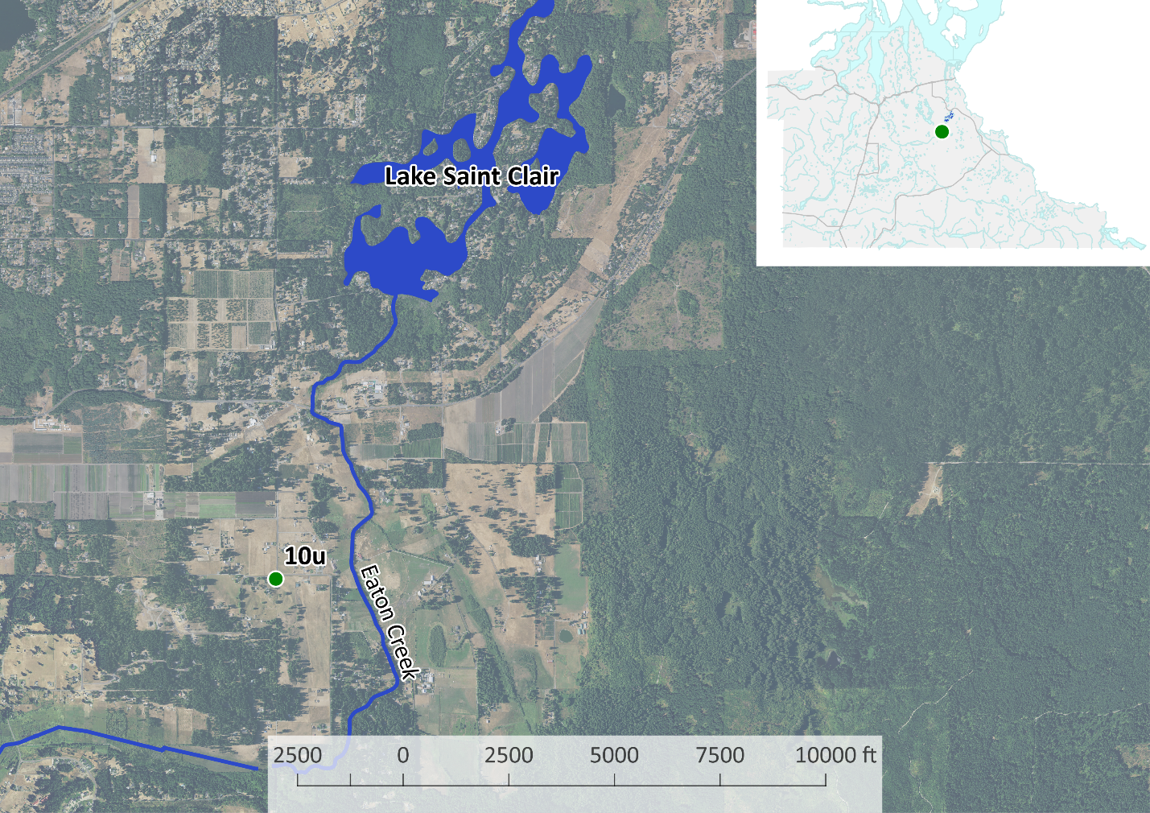

Thurston County Water Resources Technical Memorandum 7 discussed the correlation between precipitation and Lake St. Clair water elevations. This memorandum discusses the correlation between Lake St. Clair water elevations and discharges from Eaton Creek.

# Results

Technical Memorandum 7 already established the seasonal and annual trends of Lake St. Clair water elevations. The lake rises and falls over the course of each year. It also rises and falls in response to long-term trends.

Figure 1: Water Elevation Decomposition

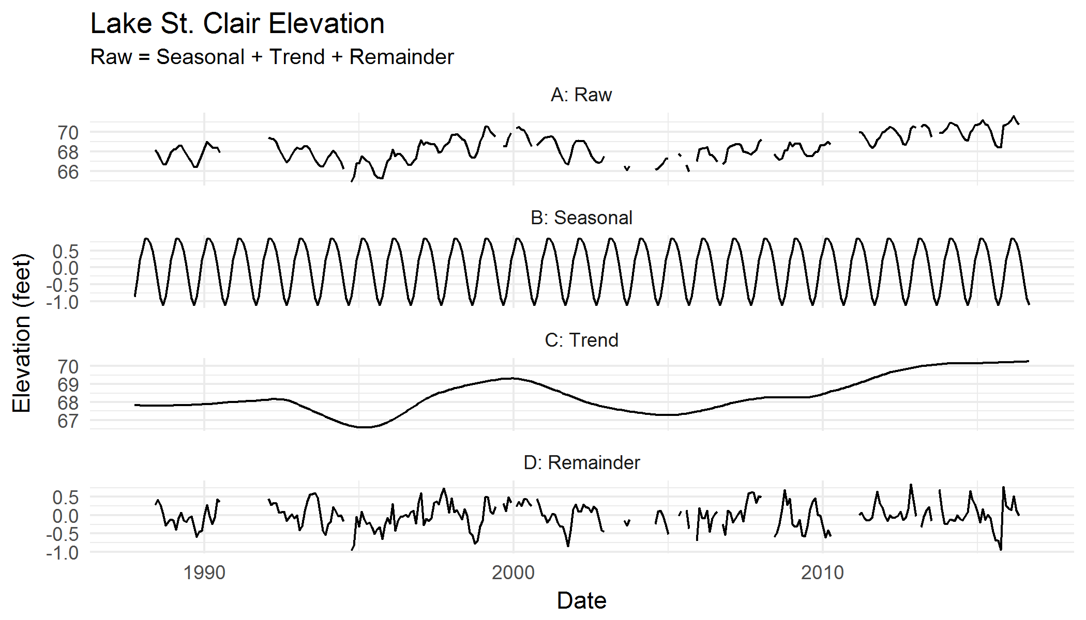

The period of record for reliable Eaton Creek discharge data is much shorter than that of Lake St. Clair elevations, beginning in 2008. Nevertheless, discharges from Eaton Creek have a similar pattern to Lake St. Clair elevations, varying by season and with long-term trends.

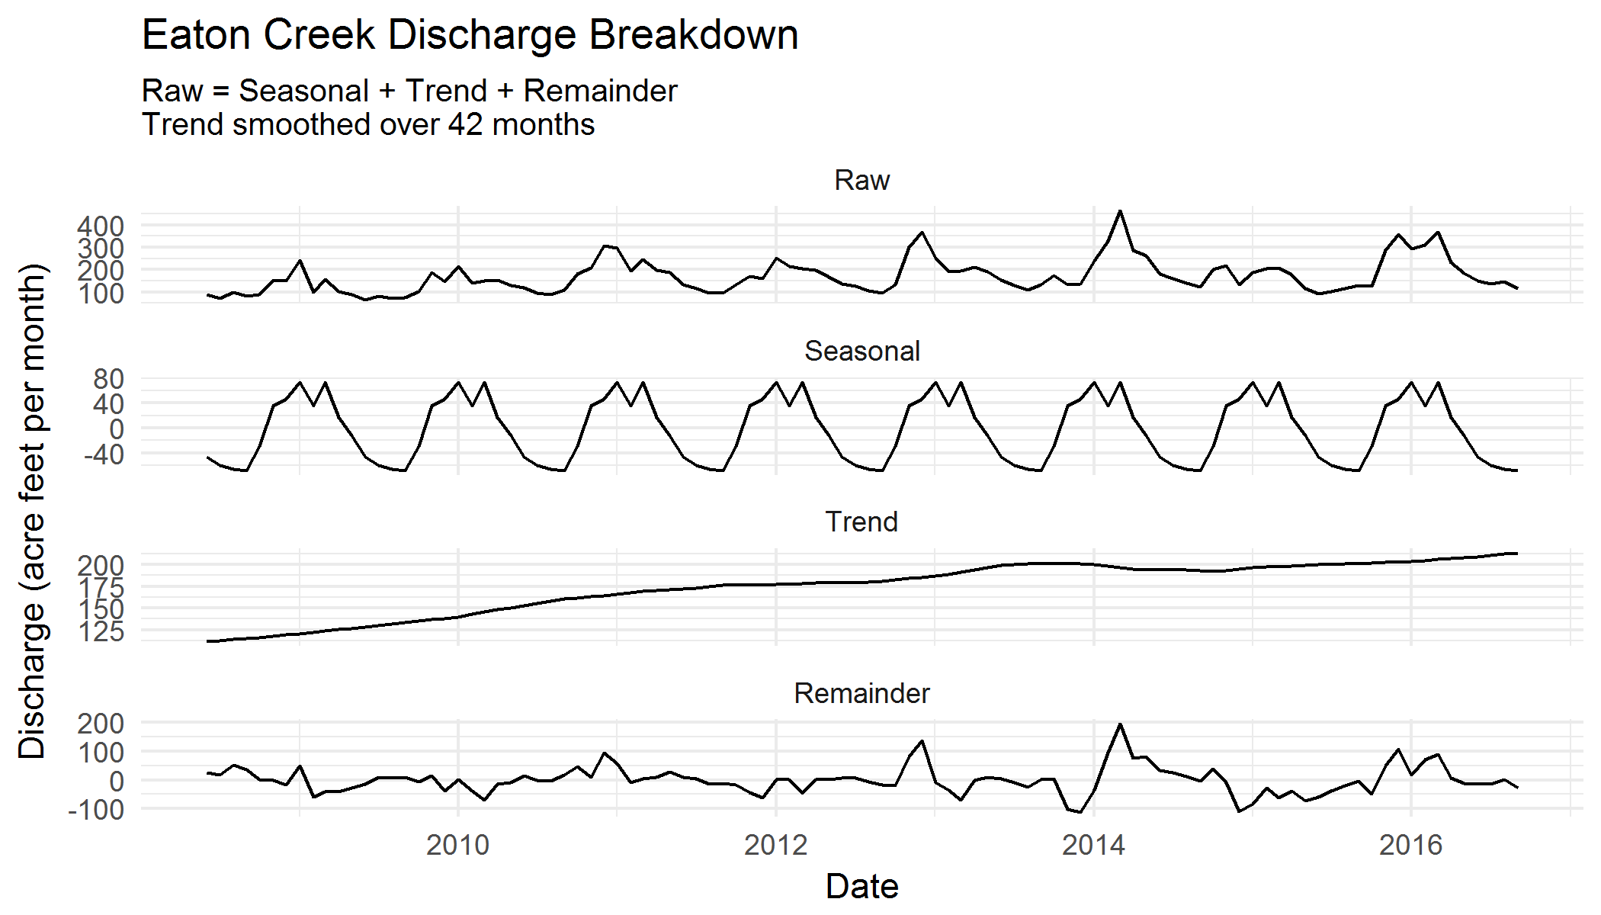

Not only does the seasonal pattern of discharge from Eaton Creek match the seasonal rise and fall of Lake St. Clair, the trend from 2008-2016 is very similar as well. The long-term trend of discharge from the creek (after accounting for seasonal patterns and random variance) increased by about 100 acre/feet per month – a notable increase for a creek with peak discharges of approximately 400 acre/feet per month.

**Eaton Creek discharges can explain approximately 60% of the variance in the elevation of Lake St. Clair.** This is very similar to the percentage explained by precipitation metrics in Technical Memorandum 7. It is likely that there is a causal chain connecting precipitation, to Eaton Creek discharges, to Lake St. Clair elevations. Groundwater is an important factor in lake elevations that these technical memoranda do not explore.

# Methods

## Software

This analysis was conducted in R 3.3.2 (RStudio 1.0.136, plus packages lubridate, stlplus, and tidyverse); QGIS 2.18; Excel 2013; and Notepad++ 7.1.

## Data

Elevation data for Lake St. Clair were obtained from Thurston County monitoring archives. Approximately twice-monthly values from 2008-2016 were available; from 1988-2008, monthly minima and maxima were available, with some breaks in the data.

Average daily discharge data in cubic feet per second (cfs) for Eaton Creek were also obtained from Thurston County monitoring archives for 2008-2016.

All data are monthly. Elevation values are monthly averages; prior to 2008 these are averages of minima and maxima; after 2008 these are averages of values obtained on specific days. Discharges are monthly sums. The average daily CFS was converted into acre/feet per day, then summed for each month to get acre/feet per month.

## Analysis

This exploratory analysis included:

* Developing a relationship between elevation and discharge.
* Breaking discharge into seasonal, long-term trend, and remainder parts.

## Relationship between Elevation and Discharge

Lake water elevation and creek discharge values for the same month were plotted against each other to determine what, if any, relationship they bore to one another. A visual inspection confirmed a positive logarithmic relationship; as discharge increases, lake water elevation increases, but the effect diminishes with higher volumes of discharge.

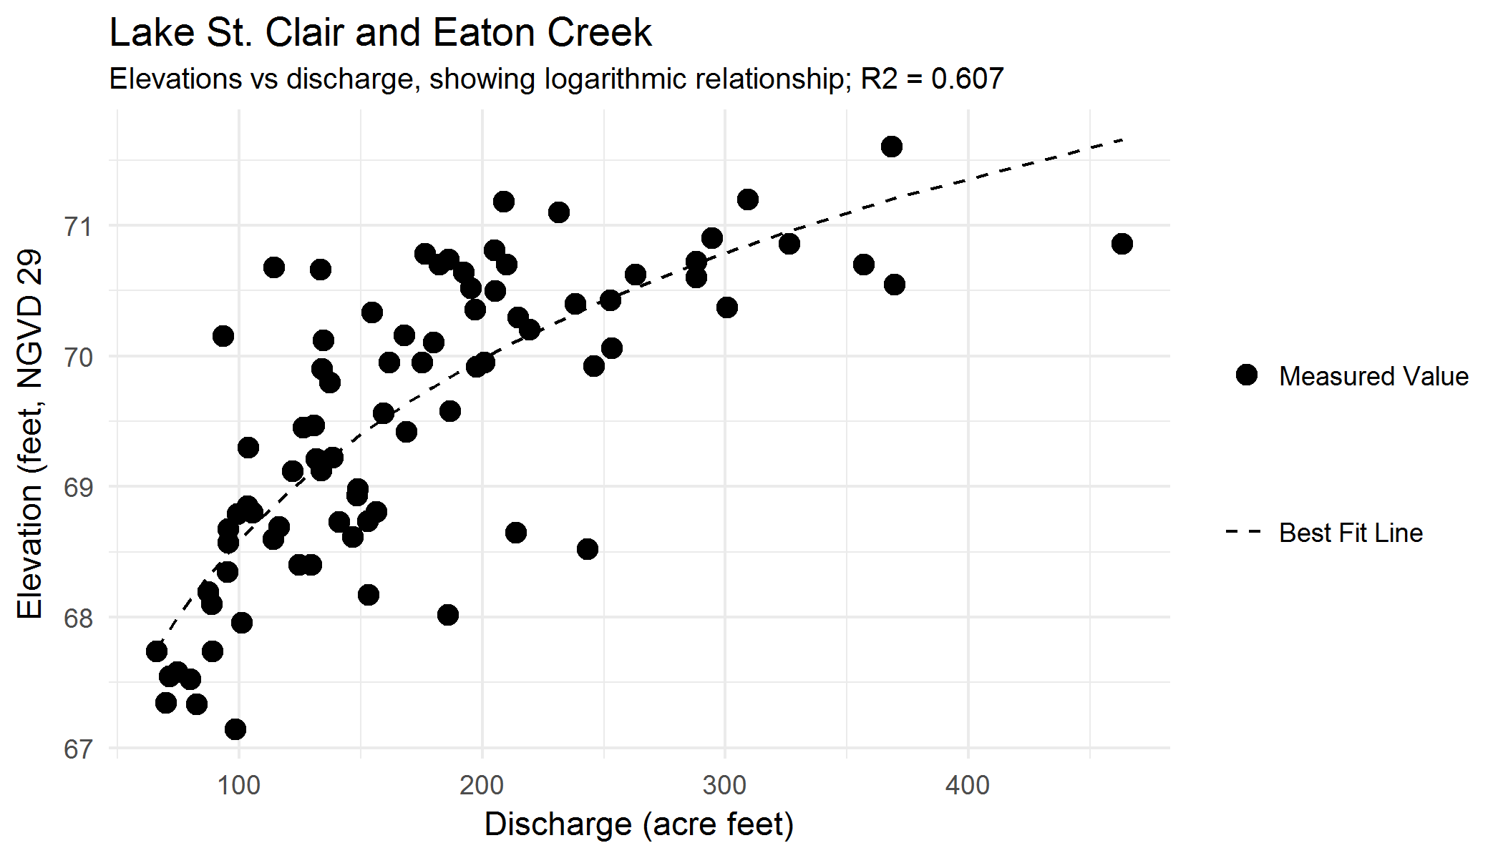

Linear and second-order polynomial equations were fit to the data. The linear fit resulted in lower R2 values and worse correlation statistics (as expected); the polynomial fit resulted in very similar correlation statistics. 6-month and 3-year cumulative discharges were fit to elevation data as well, but also resulted in lower R2 values and worse correlation statistics. Raw discharge values, with a logarithmic relationship, are the best fit with Lake St. Clair elevation. A second-order polynomial relationship gives similar correlation statistics, but visual inspection suggests that the relationship is logarithmic.

|  |  |  |
| --- | --- | --- |
| **Equation** | **R Squared** | **P-Value** |
| Elevation ~ Stage | 0.511 | 1.92E-14 |
| Elevation ~ Stage + Stage^2 | 0.604 | 2.20E-16 |
| Elevation ~ log(Discharge) | 0.607 | 2.20E-16 |
| Elevation ~ log(6 Month Cumulative Discharge) | 0.530 | 2.51E-14 |
| Elevation ~ log(3 Year Cumulative Discharge) | 0.181 | 5.05E-04 |

## Discharge Breakdown

Using seasonal trend decomposition (STL), a time series can be broken apart into seasonal variation, long-term trend, and remainder values, which can be added together to recreate the original dataset.



Eaton Creek has a predictable yearly cycle of increased discharge volumes through the winter months, followed by decreased discharge volumes through the summer months. This matches the precipitation cycle seen in the Puget Sound region, and specifically in the Lake St. Clair basin.

Discharges from the creek have also tended to increase from 2008 to 2016. There is an approximately 100 acre feet per month increase from the beginning to the end of the observed period. Since the highest observed discharge was 460 acre feet per month, and the lowest was 66 acre feet per month, the change is significant.

# Conclusions and Recommendations

## Conclusions

Thurston County Water Resources Technical Memorandum 7 established that a relationship exists between cumulative precipitation plus precipitation intensity, and the elevation of Lake St. Clair. It also recommended an investigation of the impact of Eaton Creek on the elevation of Lake St. Clair. This technical memorandum establishes that discharges from Eaton Creek explain as much of the difference in Lake St. Clair water elevations as cumulative precipitation volume and intensity combined.

The seasonal and long-term trends of discharges from Eaton Creek match seasonal and long-term trends in Lake St. Clair. However, the lack of data prior to 2008 makes comparison more difficult.

## Recommendations

# Works Cited

Cleveland, R. B., Cleveland, W. S., McRae, J. E., & Terpenning, I. (1990). STL: A Seasonal-Trend Decomposition Procedure Based on Loess. *Journal of Official Statistics*, 3-33.